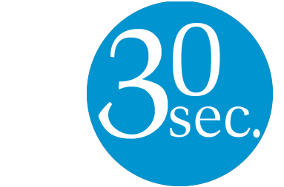
30-second evaluation

Head
To what extent did the day engage you intellectually and stimulate your thinking processes?

1 2 3 4 5 (5 = Highly Engaging)
Heart
To what extent did the day enrich your spirit and feed your soul personally and as a teacher in a Catholic school?

1 2 3 4 5 (5 = Highly Engaging)
Hands
To what extent did the day build your confidence and capacity to lead prayer modelled on the Examen

1 2 3 4 5 (5 = Highly Engaging)

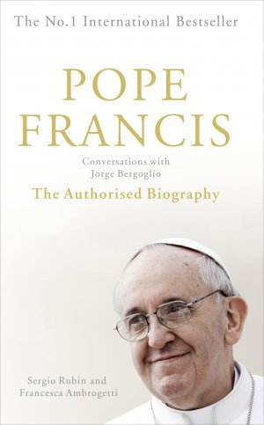
“It’s fundamental that one thinks what one feels and does; feels what one thinks and does; and does what one thinks and feels. You must use the language of the head, the heart and the hands”
(Cardinal Jorge Bergoglio)
We’d love to hear more, but you’ll need to turn over the page

Any further comments on the day?
___________________________________________________________________________
___________________________________________________________________________
___________________________________________________________________________
___________________________________________________________________________
___________________________________________________________________________
___________________________________________________________________________

Do you leave the day with any resolutions? What questions have arisen during the course of the day? What support would assist in developing further your confidence and capacity to lead the Examen.
___________________________________________________________________________
___________________________________________________________________________
___________________________________________________________________________
___________________________________________________________________________
___________________________________________________________________________
___________________________________________________________________________

