Staff Prayer for the Beginning of 2016 in
The Jubilee Year of Mercy
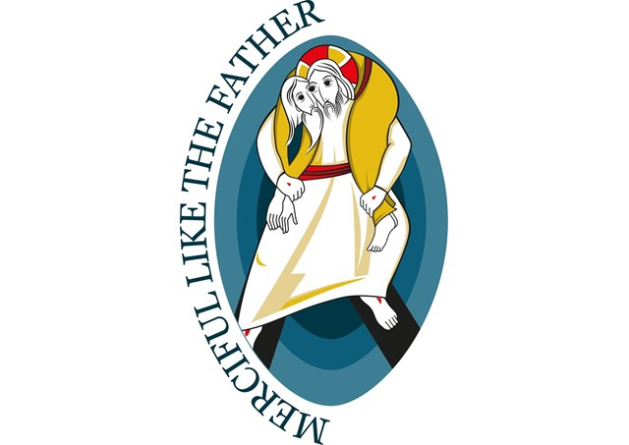
“The logo and the motto together provide a fitting summary of what the Jubilee Year is all about. The motto Merciful Like the Father (taken from the Gospel of Luke, 6:36) serves as an invitation to follow the merciful example of the Father who asks us not to judge or condemn but to forgive and to give love and forgiveness without measure (cfr. Lk 6:37-38). The logo … represents an image quite important to the early Church: that of the Son having taken upon his shoulders the lost soul demonstrating that it is the love of Christ that brings to completion the mystery of his incarnation culminating in redemption. The logo has been designed in such a way so as to express the profound way in which the Good Shepherd touches the flesh of humanity and does so with a love with the power to change one’s life”(Vatican website)

Welcome to Prayer

Principal: As we come together to begin a new year full of hope for ourselves and the children and families in our school, we reflect upon how we can develop a community of mercy as we celebrate the Jubilee Year of Mercy in the 50th anniversary year of the Vatican II Council.
AP: In the words of Pope Francis:
“God's mercy can make even the driest land become a garden, can restore life to dry bones (cf. Ez 37:1-14). ... Let us be renewed by God's mercy, let us be loved by Jesus, let us enable the power of his love to transform our lives too; and let us become agents of this mercy, channels through which God can water the earth, protect all creation and make justice and peace flourish.”
— Easter Urbi et Orbi message on March 31, 2013

REC: Please take a few minutes to relax. Become aware of your breathing. Take note of the rhythm of your breathing. Feel the expansion in your chest and diaphragm. Listen as I slowly call you to mercy and compassion.

Breathe in truth and breathe out fear.

Breathe in love and breathe out suffering.

Breathe in justice and breathe out selfishness.

Breathe in faith and breathe out doubt.

Breathe in mercy and breathe out apathy.

Breathe in compassion and breathe out.

Breathe gently now as you are called to reflect upon a great parable of mercy and compassion, the parable of the Prodigal son.

Reader:
The Parable of the Lost Son (Luke 15:11-32)
Jesus continued: “There was a man who had two sons. The younger one said to his father, ‘Father, give me my share of the estate.’ So he divided his property between them.
“Not long after that, the younger son got together all he had, set off for a distant country and there squandered his wealth in wild living. After he had spent everything, there was a severe famine in that whole country, and he began to be in need. So he went and hired himself out to a citizen of that country, who sent him to his fields to feed pigs. He longed to fill his stomach with the pods that the pigs were eating, but no one gave him anything.
“When he came to his senses, he said, ‘How many of my father’s hired servants have food to spare, and here I am starving to death! I will set out and go back to my father and say to him: Father, I have sinned against heaven and against you. I am no longer worthy to be called your son; make me like one of your hired servants.’ So he got up and went to his father.
“But while he was still a long way off, his father saw him and was filled with compassion for him; he ran to his son, threw his arms around him and kissed him.
“The son said to him, ‘Father, I have sinned against heaven and against you. I am no longer worthy to be called your son.’
“But the father said to his servants, ‘Quick! Bring the best robe and put it on him. Put a ring on his finger and sandals on his feet. Bring the fattened calf and kill it. Let’s have a feast and celebrate for this son of mine was dead and is alive again; he was lost and is found.’ So they began to celebrate.
“Meanwhile, the older son was in the field. When he came near the house, he heard music and dancing. So he called one of the servants and asked him what was going on. ‘Your brother has come,’ he replied, ‘and your father has killed the fattened calf because he has him back safe and sound.’
“The older brother became angry and refused to go in. So his father went out and pleaded with him. But he answered his father, ‘Look! All these years I’ve been slaving for you and never disobeyed your orders. Yet you never gave me even a young goat so I could celebrate with my friends. But when this son of yours who has squandered your property with prostitutes comes home, you kill the fattened calf for him!’
“‘My son,’ the father said, ‘you are always with me, and everything I have is yours. But we had to celebrate and be glad, because this brother of yours was dead and is alive again; he was lost and is found.’”

REC: Look closely into the art by Sieger Koder for a few minutes. Go around the circle saying one thing that you see ( do not say why the first time).
Look closely into the art again and this time say what strikes you and why. It may be the same thing as your first impression or something else.
Together join in the traditional song which is about the story of the Prodigal son, “ Amazing Grace.”
https://www.youtube.com/watch?v=GYMLMj-SibU
Prayer of the Faithful:
Principal: As we commence a new journey in this Jubilee Year of Mercy, we pray for ourselves and our communities.
Staff members are invited to contribute their own prayers
Response: We pray to the Lord.
REC: Gracious and merciful God we ask that you hear our prayers. We ask this through Jesus Christ Our Lord.
All: Amen

Prayer of Blessing:
Principal:
May you always remember in good times and in challenging times that you are filled with loving kindness.
May you share this in your mercy and compassion and may you experience the mercy and compassion of others.
May you know peace and love and may you know joy in your role in education.
All: Amen
